Zeal Master
Warrior's Dream

Rahmel Garner

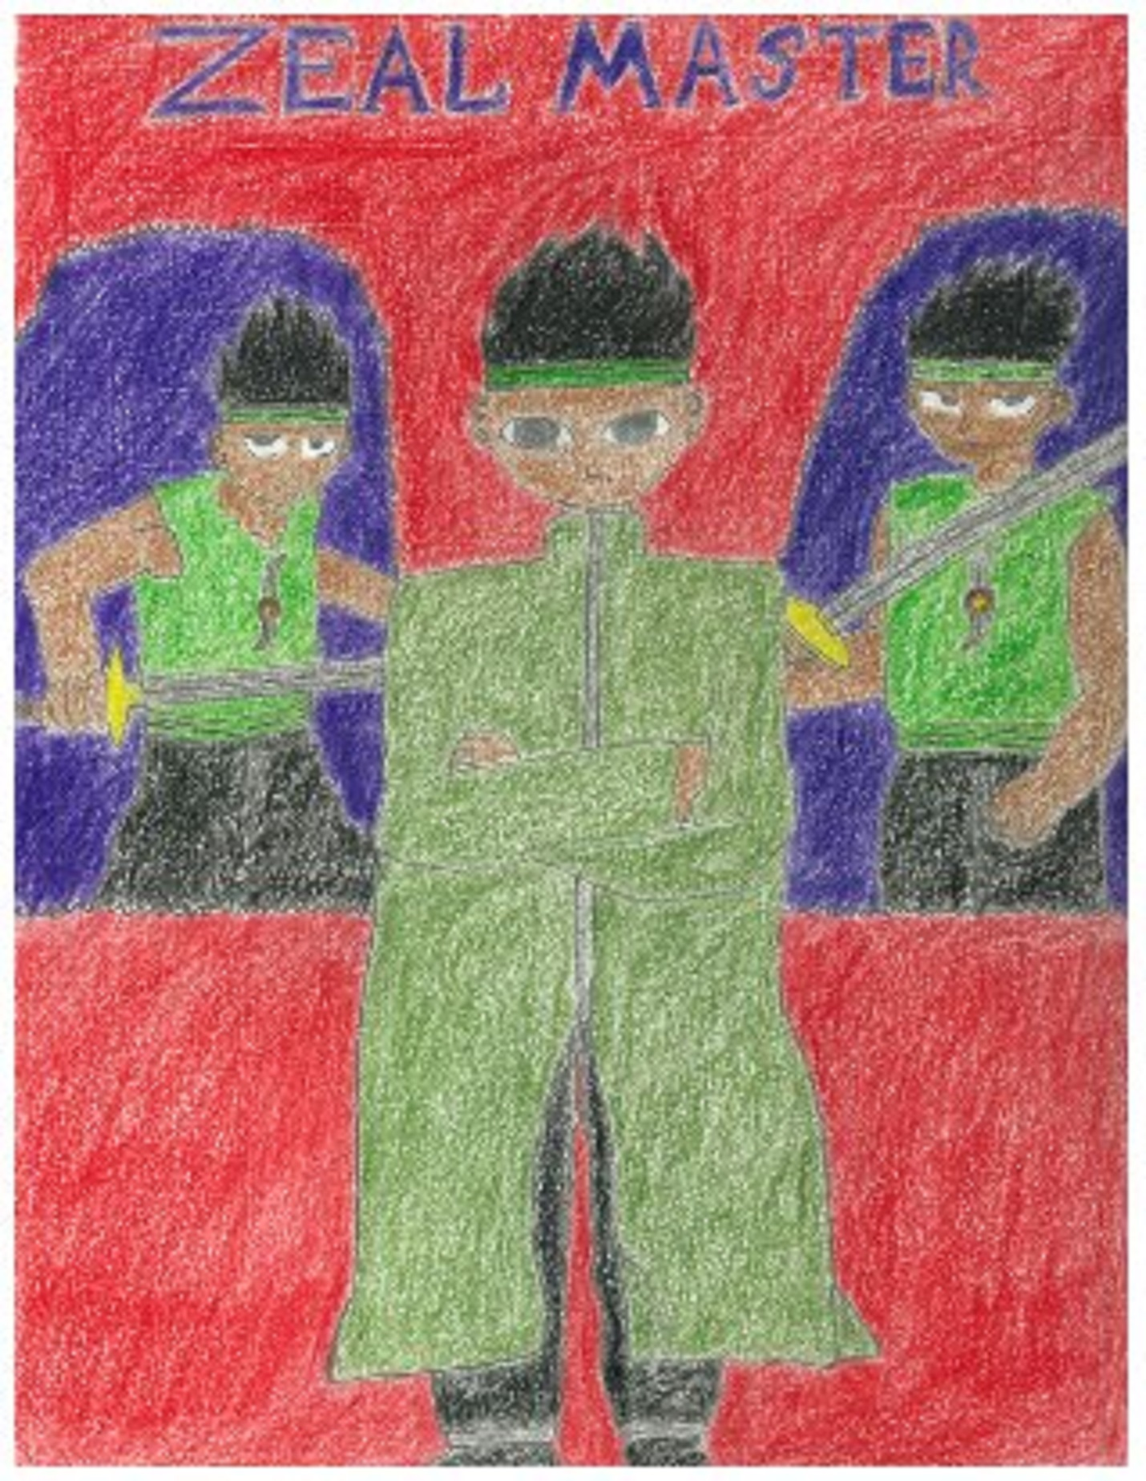

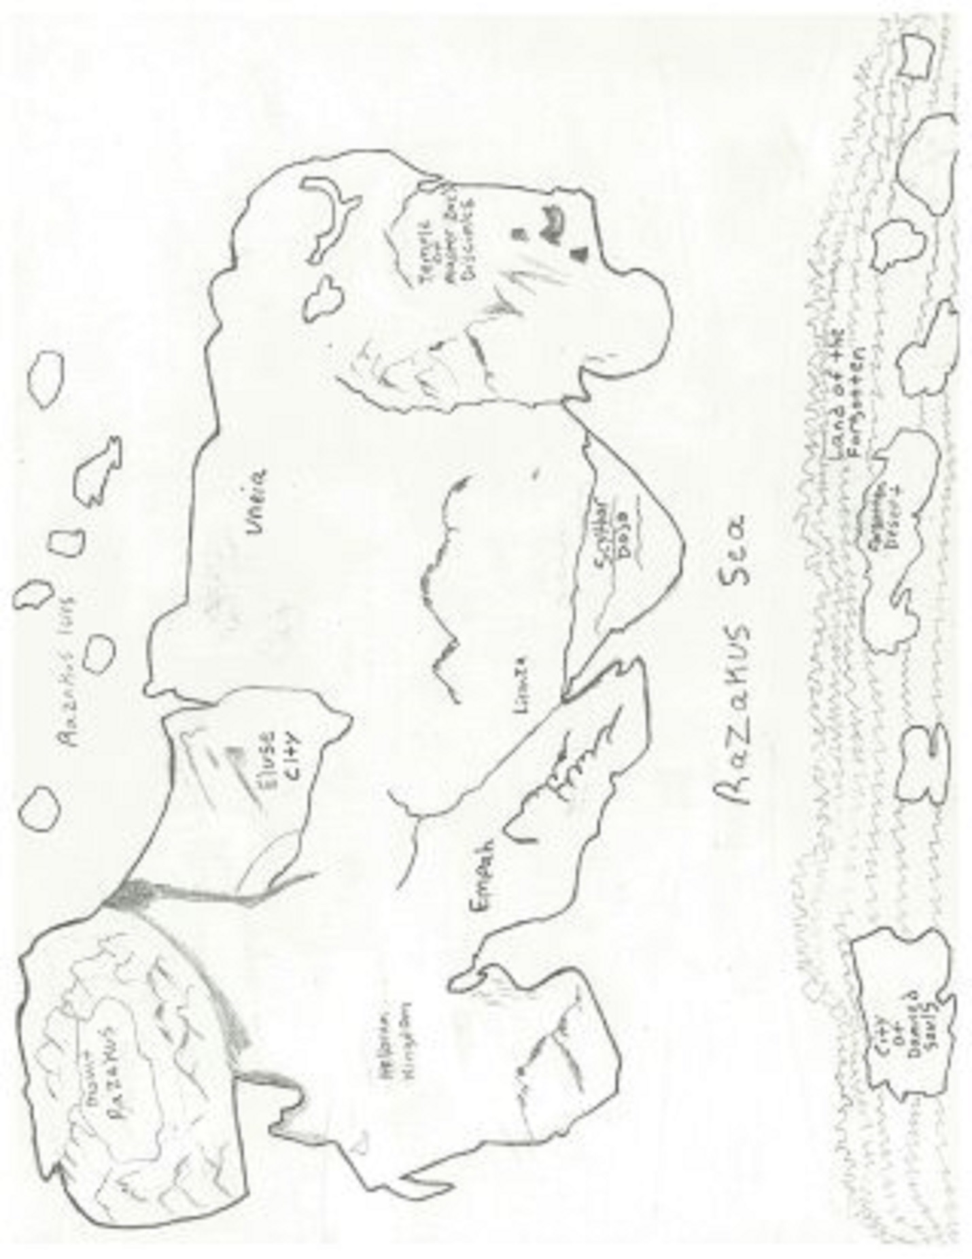

Introduction

This is a story of a forgotten time when supernatural forces ruled the earth. This world is centered-around a group of people known as “zealeths”, these people are outcasts usually shunned by the rest of the common folk who mistake them for monsters. It is not without reason though, since they can harness latent power called “zeal energy”.
They also carry a sacred mark on their body called a “zeal symbol” and the symbol location varies by zealeth-body. They are unique and because they’re unique mankind refuses to tolerate their existence. For countless centuries man and zealeth have waged wars against one another. Until one day a “zeal master” appears and brings balance back to the world.
But nothing is ever as it appears as he struggles with an ancient power known as the “fire apparition’s will.” The fire apparition’s will, has the power to destroy every living thing in the world. Long ago, the zealeths ancestors had a natural ability to fight with titanic force. Many of these beings were used by the deities who ruled at the time. Their sole purpose was to fight.
But they did not deserve to be used for such evil. Now one day a horrible event took place. The days of consecutive killing began to awaken the devil that lied dormant within them. When the devil was awakened, it was said to not only consume the person’s body, but that person’s entire being. That is the true identity of the fire apparition’s will. And the zeal master represents the last of that contaminated blood line. Unfortunately, the cycle of bad karma has not been broken.

Part One
Legend of the Zeal Master

I’ve saved the world from chaos in my own way, as destroyer of gods and slayer of dragons. The zeal inferno murder, the pinnacle of mastery of the fire apparition’s will is not a myth after all. As I remain in my lair with all five zeal stones in my possession in a complete state of bliss, I can’t help but reminisce on the trials and tribulations throughout the course of my life. I am a zealeth who was raised in the “scythor clan” and trained in the “stealth crow” style of martial arts by a master named “Rajarous”.
After my victory over my rival “Visis” in traditional scythor clan combat, I earned the right to travel the world and challenge other warriors. While on my pilgrimage of enlightenment I stumbled across an ancient temple inhabited by zealeth monks who told me of my destiny as a “zeal master.” They also told me of the great deity known as “master zore,” and of his demands for me to attain the “zeal stones.” But I did not accept their commendations as I confessed my past sins, and my internal struggle against the evil force known as the fire apparition’s will.
I told them as I began my traditional warriors pilgrimage, I became a rogue, a bandit, I took tremendous pleasure in spilling my enemy’s blood, their screams of agony were my music box, once I realized the fire apparition techniques were highly unique, I would purposely reveal them in clear sight of new opponents hoping their pride would entice them to challenge me, thus, giving me an opportunity to take another life. I suppose I wanted to prove that such condemnation is what I deserved.
For years I spent every waking moment looking for my next kill. I started to wonder if the fight against the rage mattered at all. It was not long before my former life at the scythor dojo started to become a faint shadow on the outskirts of my consciousness. The bandits, whom I had come to look upon as family, soon grew weary of my murderous habits and once again I found myself shunned.
In my solitude, I found myself gazing at my stealth crow blade for hours finding that I would be taken by a strange calm in honor of my master who taught its balance and order. And I knew I had to find one who could teach me how to master the evil within. I also told him that the ability to manifest fire apparition techniques are derived by murderous intentions and that not much is known about the origin of this destructive power.
He told me that my search had ended, and that I was the chosen one. The zealeth who possessed the zeal master’s will and the one who will bring balance back to the world. He told me to think back to my training, how it all came so naturally to

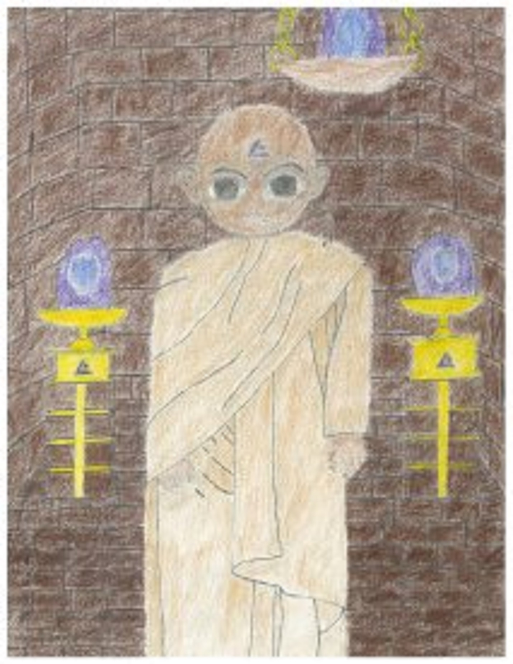
me, throughout all of those rigorous training sessions, my resilience was unlike anything rajarous had ever witnessed and I never knew why.
“Well now I’m telling you why!” he shouted as he explained that for countless centuries, countless zealeths have spoken of the one who will gather all five zeal stones together and bring balance back to the world.
“You may not want to believe it but I can see it in your eyes. But please allow me to be more convincing.” The zealeth-monk said as he attacked me and was impressed by my speed and agility. As I got ready to draw my sword I told the zealeth-monk that I didn’t want to hurt him.
“You still don’t get it do you? Yes, you are still in the material world. You have to feel it out. You have to channel all of your senses together into a sixth sense, and then you will be ready to master the zeal master’s will. Now, you must take this map and follow it to the oasis deep into the forgotten desert of the forgotten lands. There you will find master zore; I believe he will have the answers you are looking for. It has been a pleasure meeting the true zeal master.” He said as all of a sudden, a huge flash of light surrounded him and he vanished. As I began pondering amongst myself, I saw things through a completely different lens. I attained a new sense of hope and a new sense of purpose.
After my revelation at the temple of master zore’s disciples, I began my new journey to the forgotten desert. Through a few days by boat in the Razakus-sea, I made it to the forsaken land of the forgotten. And as I began traveling through the forgotten desert, out of nowhere a huge giant appeared.
“I am kavime, I am master of the land you trespass upon. I’m also a master of the sacred inferno axe and the undisputed king of empah, hill of giants. Those who cross the forgotten desert must cross through me. In the name of master zore and all of his righteousness, prepare yourself.” The giant arrogantly said as I removed my sword, my cloak and my other belongings. The poor guy brought it upon himself. As kavime began running towards me I then jumped in the air with some impressive hang time and as kavime got his axe in position to strike, on impact I suddenly vanished and kavime’s axe barreled into the ground. From a few paces behind him I shouted “you missed me!” as kavime lifted up his axe the blade began to glow and a fire like slash shot out of it as he swung the axe towards me. As the flame slash approached me I then dodged. Kavime kept slashing fire from his axe but to no avail. I was just too fast and as I kept dodging I eventually said to myself
“I maybe a small target, but this is sad.” As I began powering up, purplish flames

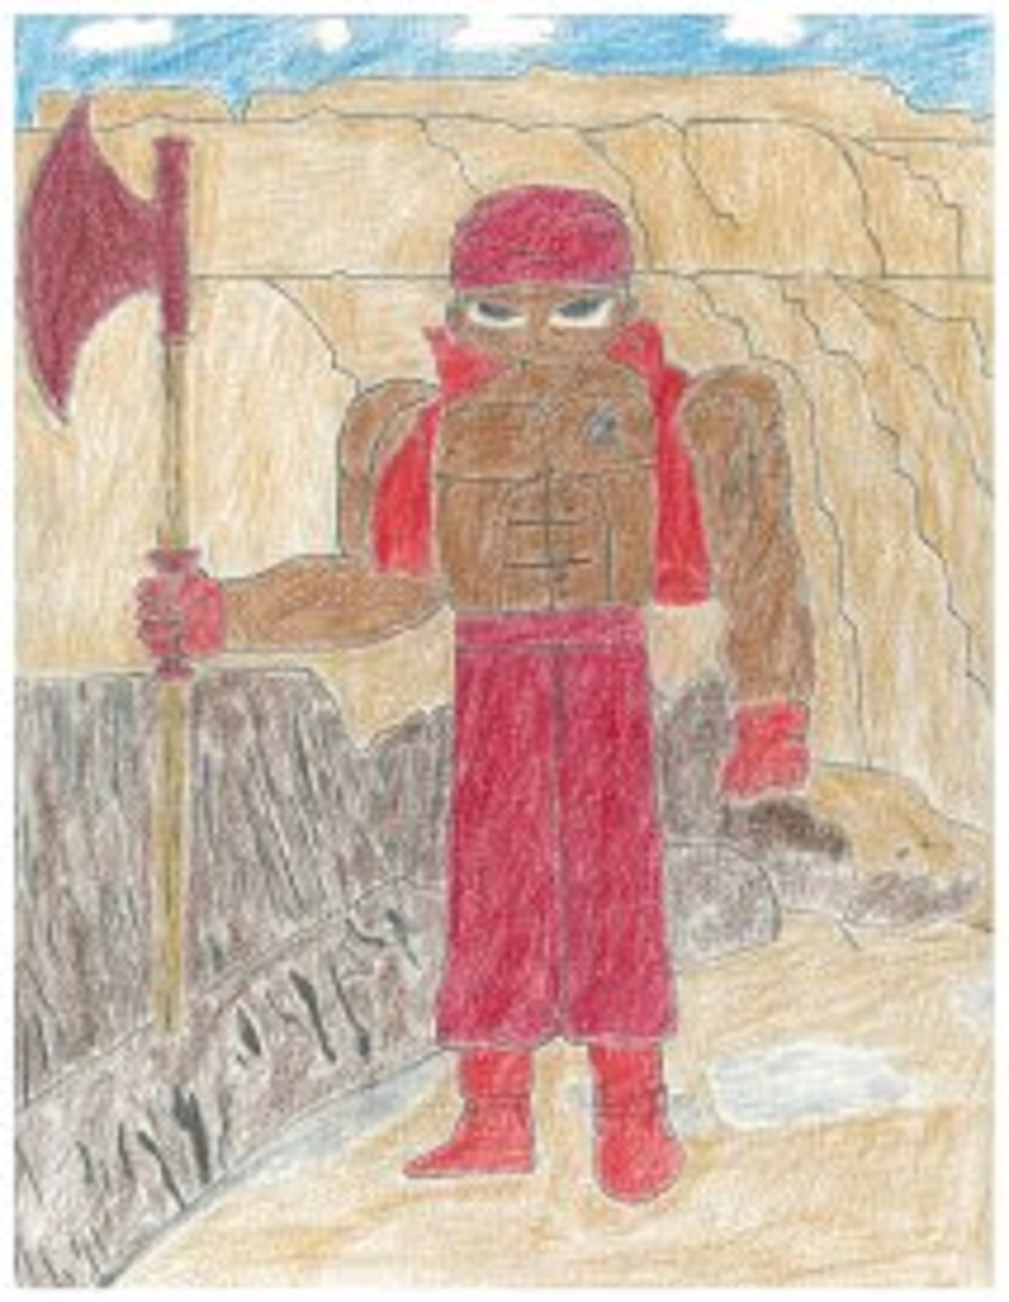
began glowing around my fists and then I shouted “fire apparition fists!” In addition, as kavime kept on slashing his flames, I knocked them away by merely punching the slashes. I was just so incredibly tough and very hard core. As kavime stopped he powered up his axe and then through it at me. As I powered up my body I began emanating a purple aura. On impact of the axe I caught it and incinerated it upon contact.

